PRESS RELEASE

COMMUNICATIONS AND MEDIA TEAM OF THE 2023 ASEAN SUMMIT

No.46/SP/TKM-ASEAN2023/ENG/5/2023

Coordinating Minister for Political, Legal, and Security Affairs Ensures Good Security on All Fronts at 42nd ASEAN Summit in 2023

West Manggarai, 8 May 2023 – The coordinating minister for Politics, Law, and Security Affairs Mahfud MD ensured that security for the ASEAN Summit at Labuan Bajo, East Nusa Tenggara (NTT), was excellent on all fronts.

"First, the security of ASEAN Summit security. Regarding security, everything has gone smoothly thus far," Mahfud stated during a visit to the Republic of Indonesia Warship (KRI) dr. Wahidin Sudirohusodo in Labuan Bajo, East Nusa Tenggara, on Monday (8 May).

Mahfud also praised the KRI dr. Wahidin Sudirohusodo as a hospital auxiliary ship (KBRS) that will provide medical care to ailing summit participants or security personnel.

“Wahidin Hospital is equipped with high-tech digital equipment and eleven specialists in order to prevent and anticipate the occurrence of health issues that require medical attention,” he stated.

KRI dr. Wahidin Sudirohusodo provides 11 specialist doctors, 28 registered nurses, one laboratory analyst, 156 treatment room beds, three intensive care unit beds, and two "high care unit"/HCU beds.

In addition, there are four sterile operating rooms, one non-sterile operating room, a dispensary and pharmacy warehouse, a mobile hyperbaric chamber, two boat ambulances, and an outpatient clinic.

Indonesia raised the theme ASEAN Matters: Epicentrum of Growth during its ASEAN chairmanship, implying that ASEAN is relevant and significant as a global growth center.

Indonesia will enhance the institutional capacity and effectiveness of ASEAN so that it can respond to challenges for the next two decades.

Indonesia serves as chairman of ASEAN in 2023, having received the "relay baton" of chairmanship from Cambodia, where the 42nd ASEAN Summit will be convened from 9 to 11 May 2023 in Labuan Bajo, East Nusa Tenggara.

The ASEAN Leaders have also begun to discuss a number of important issues in an effort to foster a more resilient ASEAN region in the face of challenges and to enhance the economic resilience of ASEAN. This endeavor is consistent with the theme carried by Indonesia's ASEAN Chairmanship: Epicentrum of Growth.

The series of the 42nd ASEAN Summit 2023 will feature eight Leaders, in addition to the Secretary General of ASEAN and the Prime Minister of Timor-Leste, to discuss a variety of ASEAN-related issues. (Foreign Affairs Ministry/TR/Elvira/SC)

***

For more information, please contact:

Director General of Public Information and Communications of the Ministry of Communications and Informatics – Usman Kansong (0816785320).

Get other information at http://asean2023.id, https://infopublik.id/kategori/asean-2023, and https://indonesia.go.id/kategori/ragam-asean-2023

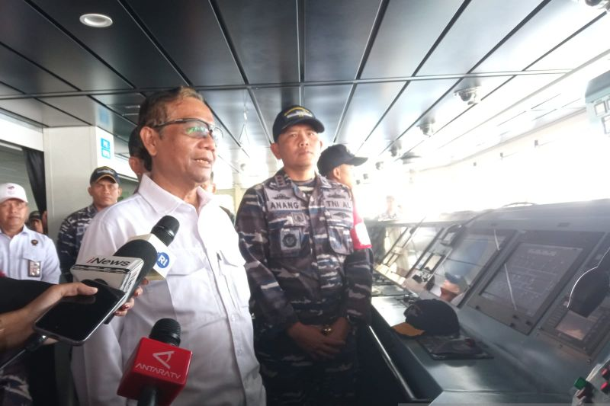

The Coordinating Minister for Political, Legal, and Security Affairs Mahfud MD visits the Republic of Indonesia Warship (KRI) dr. Wahidin Sudirohusodo in Labuan Bajo, East Nusa Tenggara, Monday. (ANTARA/ Muhammad Heriyanto)

